INDEX IN SQL

>Index is used for making your search faster by making internally B-Tree or Balanced Tree. It saves the cost(cpu%) and time.

>table scan is called as table scan and index scan is called as index seek or index scan.

>An index helps to speed up SELECT queries and WHERE clauses, but it slows down data input, with the UPDATE and the INSERT statements.

>useful when we have large number of data.

1)implicit index: Indexes are automatically created for primary key constraints and unique constraints which is called as implicit index.

2)explicit index: Which we create.

Types of index:

1)Single-Column Indexes

CREATE INDEX index_name

ON table_name (column_name);

2)Unique Indexes: does not allow any duplicate values.

CREATE UNIQUE INDEX index_name

on table_name (column_name);

3)Composite Indexes

CREATE INDEX index_name

on table_name (column1, column2);

Checking the time and cost(cpu%) required on table scan VS index scan:

Table scan:

>explain plan for

>select * from index_eg where id = 3;

output--Explained.

> select * from table(dbms_xplan.display());

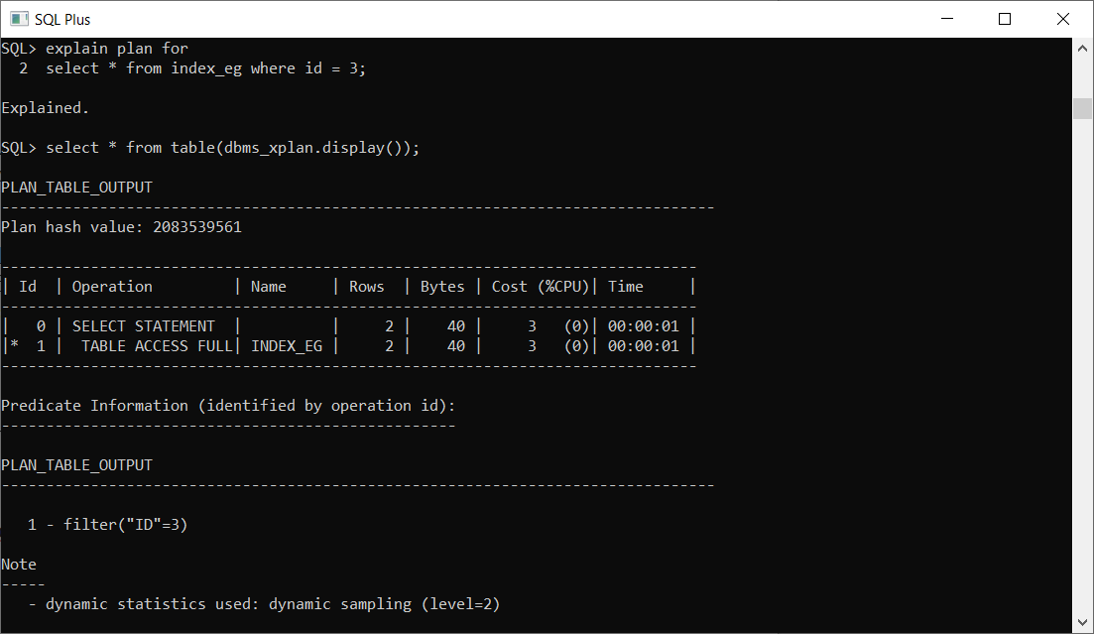

Removing index:

>drop index index_name;

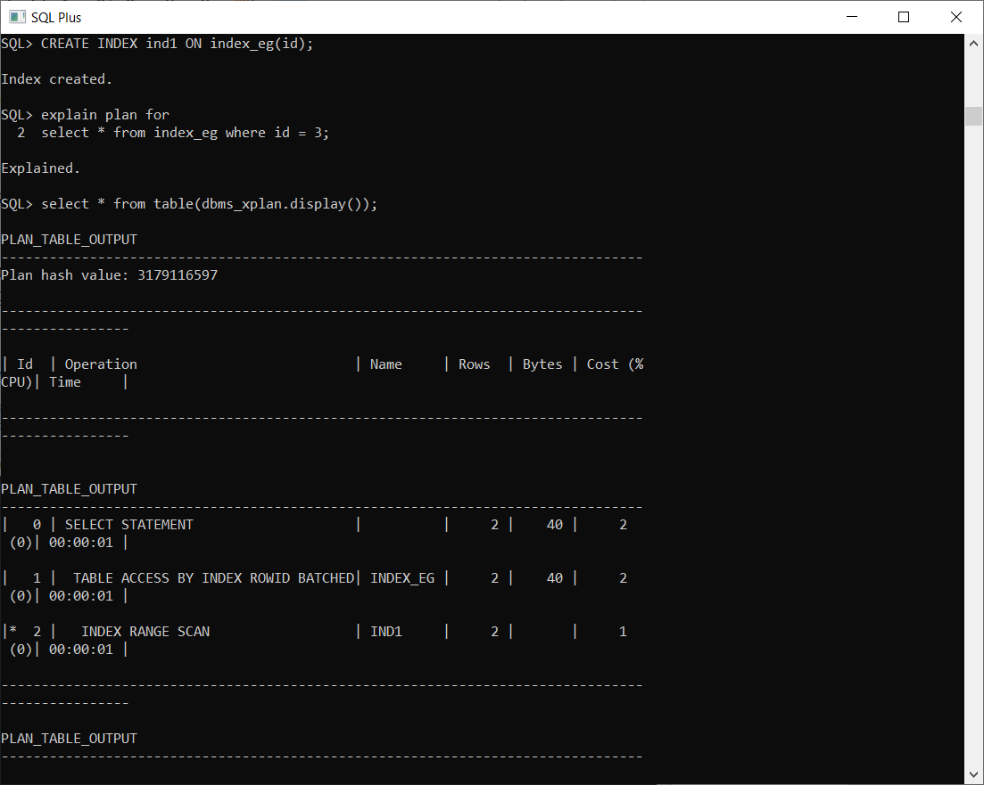Index scan:

